**FINAL REPORT**

**PROJECT OBJECTIVE**

The primary aim of this project is to provide insights and solutions for individuals who are new to freelancing and facing challenges in standing out in a competitive market. By leveraging SQL to analyze a comprehensive dataset of freelancers, this project identifies key trends, high-competition areas, and potential strategies to help newcomers navigate the freelancing landscape more effectively.

**KEY FINDINGS**

Using SQL, I conducted an in-depth analysis of the dataset, focusing on various aspects such as income, satisfaction levels, experience, education, geographical trends, and competition. The following key analyses were performed:

1. **Experience and Education:** Analysis ofhow different experience and education levels impact income and satisfaction.

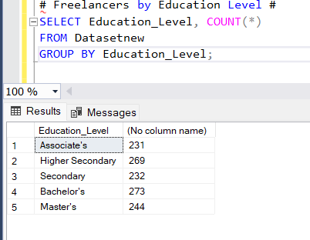

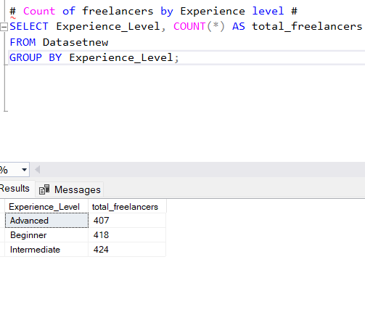

1. **Highest Paying Freelancing Fields:**
2. 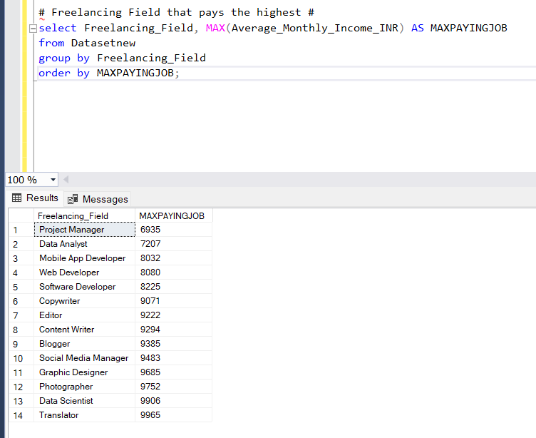

The top four highest paying jobs are:

- Project Manager

- Data Analyst

- Mobile App Developer

- Web Developer

These fields offer higher average monthly incomes, making them attractive options for new freelancers looking to maximize their earnings potential.

**3.Platform Choice:**

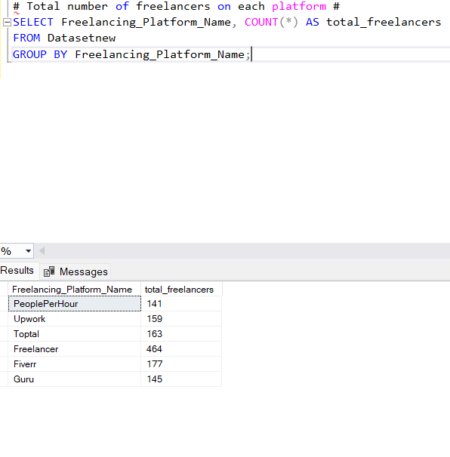

**Practical Insights for New Freelancers**

**Based on my analysis, the following insights can help newcomers stand out in the freelancing market:**

1. Skill Development: Focusing on high-paying fields such as Project Manager, data analyst, Mobile App Developer and Web Developer can significantly enhance earning potential. Investing time in developing skills in these areas can provide a competitive edge.

2. Targeting Countries: Understanding the geographical trends and focusing efforts on countries with high demand for specific skills can improve job opportunities. For instance, targeting clients in developed countries such as the USA, Germany, and the UK might offer better pay and more opportunities.

3. Leveraging Experience: Newcomers should aim to gain experience and move up from the beginner to intermediate and advanced levels. This progression can lead to higher income and better job opportunities.

4. Education: While formal education is beneficial, acquiring certifications and additional training in relevant fields can also help boost credibility and attractiveness to potential clients.

5. Platform Choice: Choosing the right freelancing platform (e.g., Upwork, Fiverr) based on the type of freelancing work and personal preferences can impact job success and satisfaction.

**Conclusion**

This project provides valuable insights into the freelancing landscape, highlighting key areas that new freelancers can focus on to succeed. By understanding high-paying fields, education requirements, experience levels, and geographical trends, newcomers can make informed decisions and develop strategies to stand out in the competitive freelancing market.